Munson’s Pickles and Preserves Farm style guide
Munson’s Pickles and Preserves Farm works to present a recognizable brand by using brand assets, fonts, and colors consistently. The following are guidelines to help you participate in creating documents for our farm.
Logos
Munson’s has 3 primary company logos
Our banner logo: Munsons_Logo_Banner_large_illustration.png   | The square version of our logo:  Munsons_Logo_Square_illustration.png  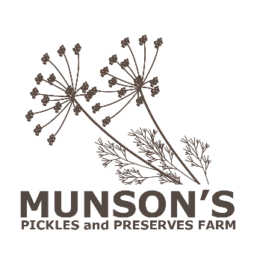
And a version of the square logo to use on dark backgrounds: Munsons_logo_Square_for_dark_background.png
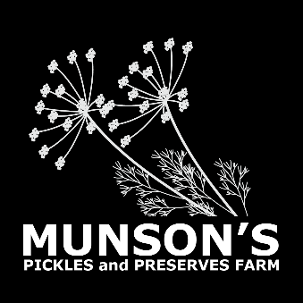
Do not alter or recolor Munson’s logos. The logo is prepared with space around it intentionally, do not crop.
Fonts
Use Verdana as a header font and either Cambria or Verdana for body text. Verdana should generally be reserved for use as a header font and Cambria as a body font. However, since sans serif fonts (like Verdana) are said to be more readable than serif fonts on digital screens, use Verdana as a body font for documents that are not going to be printed.
Fonts sizes vary depending on the delivery. Consider your audience and how they will access the documents when choosing font sizes. Create contrast and a sense of what is most important with headers and be consistent within a document. If you are using a large font, you don’t need to bold as well: use Verdana regular body weight for titles.
Sample Header 1
Sample Header 2
Sample Header 3
Sample Body text
Colors
At Munson’s, we use color with care—as a design element where necessary—and with consideration to inclusivity. Our color palette includes bright colors as well as their dark and lighter values. In addition to shades of pure grey, limit to the colors below. Our Munson’s brand Office Theme is available for your use.
Greens | Blues | Violets | Red orange | Golds | Teals
We are mindful that not everyone has the same visual abilities and therefore we make sure that the colors we select do not obscure the readability of text. It is necessary to have a strong contrast between the text color and the background color. The following table presents four good color combinations and two poor combinations.
Poor color contrast  White text on light green background | Good color contrast  Dark gray text on light blue background | Good color contrast  Dark violet text on light violet background
Good color contrast  White text on dark green background | Poor color contrast  Dark gray text on dark blue background | Good color contrast  Light teal text on dark violet background
The Office apps include a tool named Accessibility Checker. This tool will notify you when you have hard-to-read text in your document, presentation, or spreadsheet.
To use the Accessibility Checker, go to the File menu and select Inspect Document. Then, select Check Accessibility.

